McLean County Home and
Community Education News

JUNE  JULY  2025 | 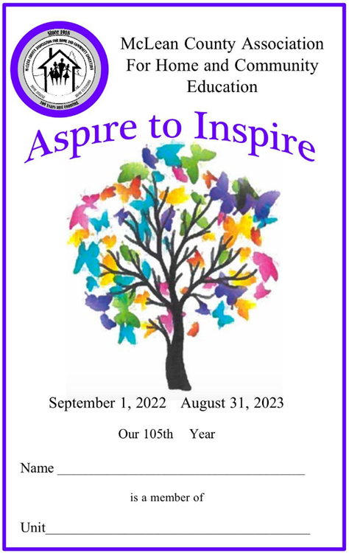
(All programs Open to Public, some with fees)
LLL = Local Leader Lesson
EX = Extension Office: 1615 Commerce Parkway, Blm
FB or FB=Farm Bureau Bldg, 2242 Westgate Dr, Blm

CULTURAL ENRICHMENT ACTIVITIES….

EAT, Shop, Visit!!!

Thursday, June 12

Thur., June 12 BUSY CORNER LUNCH & SHOP
11 am -Busy Corners Lunch  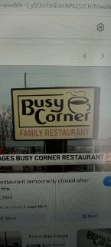  302 S Eureka St. Goodfield, IL  RSVP by Fri, June 6 to Ruth:  grppoppe@frontier.com  or text 309-287-8214  Carpooling on your own | Afterwards, Shopping  In Eureka with last stop  at Eureka College and the Reagan Peace Garden  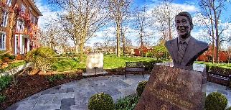

Read & Share 2-3:30p  Meet at McLean Co Extension Ofc  FREE, Public invited.  Info: LaVonne C. 309-825-6558 | 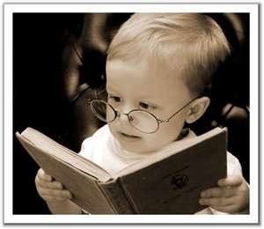

Jun 16 - The Extraordinary Life of Sam Hell by Robert Dugoni.

DIFFERENT BOOK & TITLE/AUTHOR than previously publicized

HCE INTERNATIONAL STUDY

2025  INTERNATIONAL STUDY OF  South Africa | 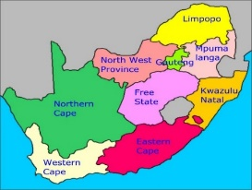
South Africa has a population of about 62 million (as of 2022) and has diverse origins, cultures, languages, and religions. The population has continued to increase from 13.6 million in 1950 and then 55.3 million in 2015. South Africa has about five million illegal immigrants, including some three million Zimbabweans. To Learn More, Attend:
**International Day, Thursday, October 9, 11a-1p**
McLean County Farm Bureau Auditorium
Kathleen Emery will speak of her South Africa Adventure

McLean County HCE MEMBERSHIP Activities
Visit a HCE unit meeting, workshop, or class for wonderful lifelong learning.
For more information of HCE membership:

Joann Hart, 309-310-9205, jh1610@aol.com
Paula Miller, 309-824-0661, pami2468@hotmail.com

Monthly Programs (September – June)
Coming to a Unit Meeting NEAR YOU!
Kathleen 309-824-2784, ksemery@frontiernet.net
Becky Toohill 309-532-2125, becktohill@aol.com

LLL(Local Leader Lessons) are free & open to the public.
FB: Farm Bureau Auditorium, 2242 Westgate Dr, Bloomington

107th Annual Meeting of the
McLean County Association for
Home & Community Education &
Cultural Enrichment & Fine Arts Show
Plan to enter your fine arts projects completed within past 2 years
Thursday, July 17, 2025 8:30 am - 1:00 pm
St. John’s Lutheran Church,
1617 E Emerson St, BLM Lower Southside entrance (no stairs)

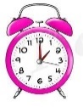 | “MAKE TIME”  for  McLean County HCE

Tickets: $20
Business meeting, officers installation, program and luncheon. Rosemary Martin, 309-473-2876

8:30-9:00 Registration & Fine Arts & Crafts projects brought in
9:00 Annual Meeting with program & luncheon to follow.
Program: Dr. Michael Lockett, Storyteller/Author
Fine Arts & Craft Show will be going on with judging & winners to go to state announced after the program.

McLean County Fair  And 4-H Show  July 23-27, 2025 | 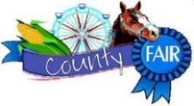

 | Thursday, July 24  Young at Heart Day at the  McLean County Fair  8:30-11:30am  Cloverleaf Auditorium

Refreshments, musical entertainment, Educational

booths of organizations serving seniors,

and LOTS OF FUN

Call one of the Chairs for more information:

Cindy Kelley, 309-824-4797; Donna LaMar, 309-829-2537
Next YAH Meeting: Thu, June 26 , 7pm @ Donna’s
May 27 2025
Information is subject to change Page 1
McLean Co HCE Newsletter
June/July 2025

107th YEAR  McLean County  Home & Community  Education | MAKE TIME    For McLean County HCE

Serving the Community. . . . . . . . . .

HCE COMMUNITY SERVICE DAY  Tuesday, Jun 17 ~ 9a - 2p  Focus Project: Patriotic Clothing Protectors  Farm Bureau- 2242 Westgate Dr, Bloomington  Come & go as needed | 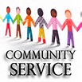
Bring your own projects or work on HCE focus projects. Bring your machine if you have one. We have two sewing machines available for those who sew but have no machine. We can always use more sewers. Kits are available for those who like to work from home. Non sewers are also welcome...we have projects for you also!!
Questions: Betty Jensen, 309-531-2183 bjgrannie@hotmail.com

SOLDIER PROJECTS

Questions/Contact: Cindy Kelley 309-824-4797

FAMILY ISSUES

2025-2026 special project to have collections for

Humane Society of Central Illinois

Gina McDannold, Chair - 309-242-3801 or

JunkerGina@yahoo.com

VOLUNTEER YOUR TIME with CVH & RSVP
HCE Community Volunteer Hours – CVH Chair will accept your volunteer hours. Contact info:
Paula Miller: 309-824-0661, pami2468@hotmail.com

McLean County HCE is a RSVP agency. If already a RSVP volunteer, your HCE hours can be reported to RSVP. If not a RSVP,
learn about signing up today.
Pat Pulokas, 309-530-5327 or palp@mchsi.com

National Volunteer Outreach Network
“Planting Many Seeds…Expect Growth”
NVON  26th Annual Conference  July 8-10, 2025  Springfield,  Illinois !!  RSVP due June 1, 2025 |   www.nvon.org  (For more details)
A delegation from McLean County is attending!
More information: Cindy Kelley, 309-824-4797

Website: www.mcleanhce.org

Do you have HCE Information to put on our public sites?
Website: Paula Miller- 309-824-0661 or pami2468@hotmail.com
Facebook: Robin Bagwell- 309-750-6715 or bobbinlace@frontiernet.net
Newsletter: Pat Pulokas- 309-530-5327 or palp@mchsi.com

LIKE our facebook page at: McLean-County-Association-for-Home-and-Community-Education.
$$$ MONEY MATTERS $$$

2025 HCE Bake Sale Booths
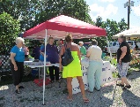 | Downs Village Market @ Dooley Park  Wed, 4-6 p.m. Jun 4 & Sep 10  Bloomington Downtown  Farmers Market  Sat, Aug 9 7:30a - 12 noon  Attic Treasures & Bake Sale  Thu, Sep 25, 3-7p; & Fri, 26, 8a.–1p

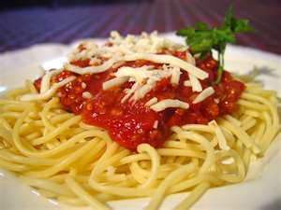  Avanti spaghetti, bread, salad homemade desserts  & drinks | Towanda HCE  Spaghetti Supper  Thursday, July 3, 2025  4:30-6:30 pm  Towanda Community Building  At the door tickets:  Adult/$10 Child/$5 (2-7 yr)  Under 2 yr. FREE  309-824-4797

Towanda Fireworks when dark on Thurs., July 3, 2025

SAVE THE DATES:

HCE Attic Treasures & Bake Sale

Thur, Sep 25, 3-7pm & Fri, Sep 26, 8am-1pm

McLean County Fairgrounds

Mini Expo Building

Holiday, Christmas, household, books, small furniture, linens, crafts, baked goods and so much more! We do NOT sell footwear or clothing but we do sell purses, scarves,

and jewelry. More details- 309-824-4797

Set up & Bring priced items on Wed, 9a-3pm.

Sale Proceeds to benefit: HCE Community Outreach Projects and HCE Scholarship(s) Fund.

IAHCE DISTRICT 2 WORKSHOPS

***Wed, June 25 Mini meeting in Decatur, IL ***

11:45a- lunch provided, donation bucket RSVP Jun 20

***Wed., August 6, 2025 ***

Southern View Chapel, Springfield, IL

More details to come

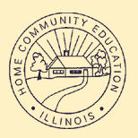 | 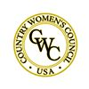 | 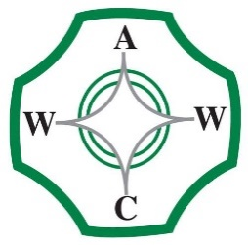

McLean County Association for Home and Community Education is affiliated with:

Illinois Association for Home & Community Education (IAHCE)

National Volunteer Outreach Network (NVON)

Country Women's Council USA (CWC)

Associated Country Women of the World (ACWW)

3
May 27, 2025
Information is subject to change Page 2

