McLean County Home and
Community Education News

AUGUST  SEPTEMBER  2025 | 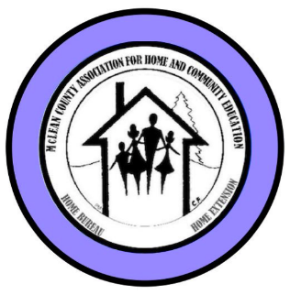
(All programs Open to Public, some with fees)
LLL = Local Leader Lesson
EX = Extension Office: 1615 Commerce Parkway, BLM
FB or FB=Farm Bureau Bldg, 2242 Westgate Dr, BLM

CULTURAL ENRICHMENT ACTIVITIES….

Sept 15, 2-3:30 p.m. – Ext Office READ & SHARE
The book: The Women by Kristin Hannah
LaVonne Cunningham 309-825-6558

Oct 16, 9:45 a.m. – Tour of the Old School House
at Weldon Springs State Park, 11:30 a.m. followed by Lunch at LaTeaDa Tea Room & Gift Shop, Clinton
Becky Toohill 309-532-2125 becktohill@aol.com

Nov 13, 9 a.m. – 12 noon – COOKIE EXCHANGE
More details to come. Contact Ruth Poppe:
grppoppe@frontier.com or text 309-287-8214

Nov 17, 2-3:30 p.m. – Ext Office READ & SHARE
The book: Remarkably Bright Creatures
by Shelby Van Pelt
LaVonne Cunningham 309-825-6558

2025-2026 HCE COMMUNITY SERVICE DAY  Tuesday, Sept 16 ~ 9a – 2p  Focus Project: Christmas stockings  Farm Bureau- 2242 Westgate Dr, BLM | 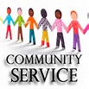
We get together to work on crafts or other special projects.
We’ll be making stockings & Strip blankets in Oct. Bring sewing machine if you have one. Sewers and non-sewers welcome. Plenty of jobs for everyone. Come & go as you are able. We need YOUR HELP to help those less fortunate. Free
Betty Jensen, 309-531-2183 bjgrannie@hotmail.com
Next CS days: Oct 21 Nov 18 Jan 20 Feb 17

HCE INTERNATIONAL DAY – SOUTH AFRICA

Thursday, October 9  11 a.m. – 1 p.m.  McLean County Farm Bureau  2242 Westgate Dr, Bloomington | 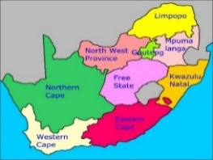

Kathleen Emery will speak of her wonderful visit to South Africa that include the safaris she went on and the foods, sights and sounds of her adventures.
More Info: Nancy Erickson – 309-378-4352
McLEAN COUNTY HCE MEMBERSHIP

Visit an HCE unit meeting, workshop, or class for wonderful lifelong learning.
For more information about HCE membership:

Paula Miller, 309-824-0661, pami2468@hotmail.com

Monthly Programs (September – June)
Coming to a Unit Meeting NEAR YOU!
Kathleen 309-824-2784, ksemery@frontiernet.net
Becky Toohill 309-532-2125, becktohill@aol.com

LLL(Local Leader Lessons) are free & open to the public.
FB: Farm Bureau Auditorium, 2242 Westgate Dr, Bloomington

August 26: Super Tuesday at Farm Bureau Auditorium
8:30a - Exec Board 10:00a - Full Board
12:30-1:30p – Lunch, provided by board
1:30-2:30p LLL – Death by Chocolate by Kathleen Emery
2:30-3:30 pm - Unit Officers Orientation-
Sept Death by Chocolate LLL @ FB, Aug 26, 12:30-2:30p
Oct Let’s Talk Pumpkins– LLL-FB -Tues,Sep 23 12:30-2p
Nov- Herbal Teas by Fusion Brew – LLL- @ FB, Tu Oct 28 12:30-1:30p

2026
Jan- Altering Recipes LLL @ FB, Tue Nov 25 12:30-1:30p
Feb- Food Labels & Food Storage LLL@FB, Tue Jan 27 12:30-1:30p

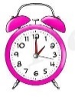  MAKE TIME | HCE Minor Lessons for 2025  Sept South Africa – Nature, Wildlife & Tourism  Oct South Africa- Foods & Traditions  Nov South Africa- Government & Flag

HCE ATTIC TREASURES
& BAKE SALE

Thu, Sep 25, 3 - 7 p.m.  Fri, Sep 26, 8 a.m. - 1 p.m.  Interstate Center  Mini Expo Building  1106 Interstate Center Dr.,  Bloomington  Enter through south entrance  Follow signs/directions | 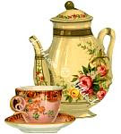

Holiday, Christmas, household, books, small furniture, linens, Crafts, baked goods and so much more! We do NOT sell footwear or clothing, but we DO sell purses, scarves, and jewelry.

More details- 309-824-4797

Members & Friends bring PRICED items, WED, Sep 24, 9a-3p

Sale Proceeds to benefit:
McLean County HCE Community Outreach & Community Service Projects including scholarship(s) for 4-H

FAMILY ISSUES

2025-2026 special project to have collections again this year for

Humane Society of Central Illinois

Sept - 8 ½ x 11 copy paper reams

Oct- Paper towels or bleach

Nov- canned cat food, poop bags

Dec- Gift cards to: Walmart, Meijer, Target, Dollar Stores

Gina McDannold, Chair - 309-242-3801 or

JunkerGina@yahoo.com
September 6, 2025
Information is subject to change Page 1
McLean Co HCE Newsletter
August/September 2025

108th YEAR  McLean County  Home & Community  Education | MAKE TIME    For McLean County HCE

Serving the Community. . . . . . . . . .

SOLDIER PROJECTS

Questions/Contact: Cindy Kelley 309-824-4797

VOLUNTEER YOUR TIME with CVH & RSVP
HCE Community Volunteer Hours – CVH Chair will accept
your volunteer hours. Contact info:
Paula Miller: 309-824-0661, pami2468@hotmail.com

McLean County HCE is an RSVP agency. If you are already an RSVP volunteer, your HCE hours can be reported to RSVP. If not an RSVP, learn about signing up today.
Pat Pulokas, 309-530-5327 or palp@mchsi.com

Save the Dates . . . . . . . . . . .

McLean County HCE

Membership/Friendship TEA

Saturday, February 14, 2026

1 – 3 p.m.

Christ Lutheran Church, Normal

The Making of Miniatures

Presented by Beverly Keller

309-825-8458

102nd IAHCE Annual Conference

March 17-19, 2026

Thelma Keller Convention Center

Effingham, IL

“EXPERIENCE THE MAGIC””

McLean County 108th Annual Meeting &

Cultural Enrichment & Fine Arts Show

Thur., July 7, 2026 – Christ Lutheran Church

Young at Heart at the

McLean County 4-H Fair

Thursday, July 30, 2026 8:30-11:30 a.m.

Website: www.mcleanhce.org

Do you have HCE Information to put on our public sites?
Website: Paula Miller- 309-824-0661 or pami2468@hotmail.com
Facebook: Robin Bagwell- 309-750-6715 or bobbinlace@frontiernet.net
Newsletter: Pat Pulokas- 309-530-5327 or palp@mchsi.com

LIKE our facebook page at: McLean-County-Association-for-Home-and-Community-Education.

$$$ MONEY MATTERS $$$

2025 HCE Bake Sale Booths Coming Up
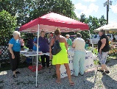 | Downs Village Market - Dooley Park  Wed, 4-6 p.m. Sep 10  Attic Treasures & Bake Sale  Thu, Sep 25, 3-7p; & Fri, 26, 8a.–1p  El Paso Fall Festival-South Point Park  3:30-6:30 Fall/Halloween

PICTURES FROM JULY, 2025
Young At Heart at the Fair – Thursday, July 24

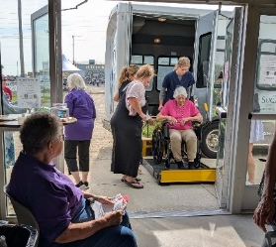  Seniors Arrive  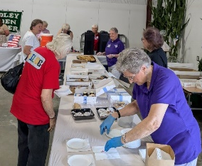  Food & Drinks enjoyed  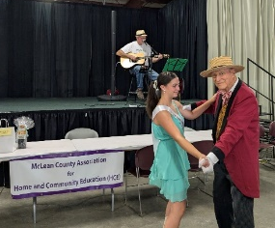  Dancing to David Berchtold  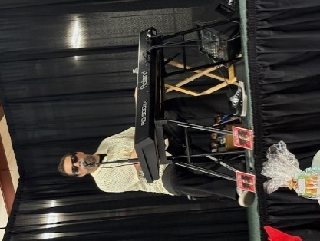  Terry Lee Ridley energized  All with his lively music! | 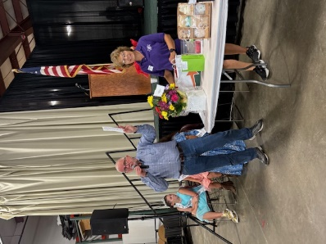  Don calls door prize winners  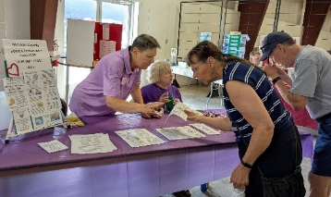  McLean HCE booth at YAH  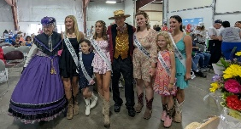  Dancers & Fair Court  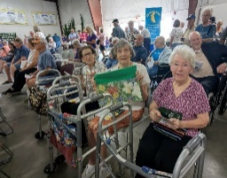  Attendees at YAH  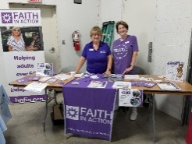  One of 15 Vendors

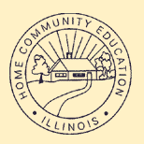 |   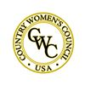 | 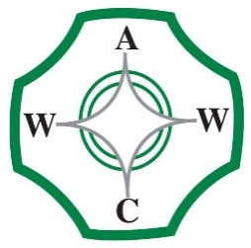

McLean County Association for Home and Community Education is affiliated with:

Illinois Association for Home & Community Education (IAHCE)

National Volunteer Outreach Network (NVON)

Country Women's Council USA (CWC)

Associated Country Women of the World (ACWW)

3
September 6, 2025
Information is subject to change Page 2

