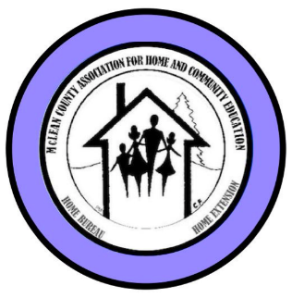  2025-2026 | McLean County Association for  Home & Community Education  107 Years of History  OUR 108th YEAR!  COME LEARN WITH US! | MAKE TIME  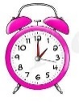  for  McLean County HCE  2025-2026

OCTOBER IS HCE MONTH

CHECK OUT ALL THE ACTIVITIES THAT Home and Community Education
HAS TO OFFER! ALL ACTIVITIES ARE OPEN TO THE PUBLIC

Visit our McLean County HCE Website www.mcleanche.org

For more information about McLean County HCE membership:
Paula Miller – 309-824-0661 pami2468@hotmail.com

INTERNATIONAL DAY to STUDY South Africa
Thursday, October 9  11 a.m. – 1 p.m.  McLean County Farm Bureau  2242 Westgate Dr, Bloomington | 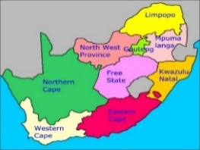
Kathleen Emery will speak of her wonderful visit to South Africa that include the safaris she went on and the foods, sights and sounds of her adventures.
More Info: Nancy Erickson – 309-378-4352

Cultural Enrichment
2025 COOKIE EXCHANGE -
Thursday, November 13, 9a–12n
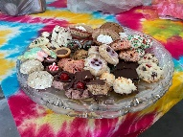  Bring 2-3 dozen cookies & extra containers to put cookies in | Farm Bureau Auditorium  2242 Westgate Dr, BLM  For more details &  RSVP with recipes by Nov 1 to Ruth @ grppoppe@frontier.com or  Or Debi 309-825-8458  Class size limited!

Come have some fun with us.

FAMILY ISSUES/COMMUNITY OUTREACH PROJECTS
Gina McDannold, chm, 309-242-380131
junkerGina@yahoo.com

2025-2026 collections for Humane Society of Central Illinois

Bring different items each month.

Oct- Paper Towels, Bleach

Nov- cans of any kind of cat food / poop bags

Dec – gift cards to Walmart, Meijer, Target,

Dollar Stores

CULTURAL ENRICHMENT

Tour & Lunch
Thursday, Oct 16  Weldon Springs One  Room Schoolhouse Tour  (follow signs)  9:45 schoolhouse tour  11:30 Lunch at La Tea Da Tea Room  in Clinton, IL | RSVP – Becky,  309-532-2125  For lunch, tour  or both  Carpool & Shopping  on your own.

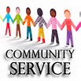 | HCE COMMUNITY SERVICE DAY  Tuesday, Oct 21 9a-2p

This workshop is at the Farm Bureau Auditorium, 2242 Westgate Dr, Bloomington. We're making Xmas stockings and Strip Blankets Take home projects are available if a person cannot attend a CS day. Come and go as you are able. The public is welcome, sewers and non-sewers needed & invited.. Plenty of jobs for everyone!

For more info: Betty, 309-531-2183.

Next CS Days: Nov 18 Jan 20 Feb 17 Mar 10 Apr 16

Local Leader Lesson:

“Herbal Teas” by Fusion Brew

Oct 28 - 12:30-1:30p

Farm Bureau Building Auditorium

More Info: Becky, 309-532-2125

2025 October Unit Meeting Program

at Unit Meetings near YOU !

Program: Let’s Talk Pumpkins

Information is subject to change October 09, 2025

Page 1
October/November 2025
McLean Co HCE Newsletter

(All programs Open to Public, some with fees)
LLL = Local Leader Lesson
EX = Extension Office: 1615 Commerce Parkway, BLM
FB =Farm Bureau Bldg., 2242 Westgate Dr, BLM

MONEY MATTERS………….
HCE Bake Sale Booths:  ****El Paso Fall Festival****  South Point Park  Sat, Oct 25, 3:30-6:30  ***Old Rugged Barn*****  Sat, Dec 13 - 10 am – 3 pm | HCE Fannie May Candy Day Fundraiser  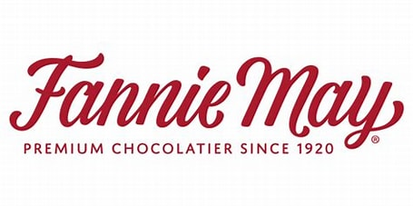  307 Veterans Pkwy, Suite 512  Normal, IL 61776  Dec 5 12n-4pm  HCE workers will hand out flyers at the door & HCE  will earn 30% of sales!
Next Fannie May in store sale day- Fri, March 20, 2026 12n - 4pm!

SERVING THE COMMUNITY…….

SOLDIER/VETERANS PROJECTS
Soldier/Veteran Care Packages may be delivered at the end of October. We collect supplies to take to Veteran’s care facilities.
Bring items to board meetings.
Cindy Kelley – 309-824-4797 or ckek71@frontier.com

VOLUNTEER YOUR TIME……….

HCE Community Volunteer Hours - CVH
Paula Miller, CVH chairman, will receive your hours monthly or quarterly etc. Important to REPORT. VERY Important !
Contact Info: 309-824-0661, pami2468@hotmail.com

McLean HCE is a YWCA – RSVP Agency
(Retired & Senior Volunteer Program)
If you are already a RSVP volunteer, your HCE hours now count as for RSVP too. If you are not a RSVP volunteer, you can learn about the benefits of volunteering your time to over 78 other agencies under the RSVP umbrella.
Contact our HCE coordinator for our RSVP link & info:
Pat Pulokas, 309-530-5327 or palp@mchsi.com

Read & Share 2-3:30p  Place: Extension Office  FREE, Public invited  Info: LaVonne C. 309-825-6558 | 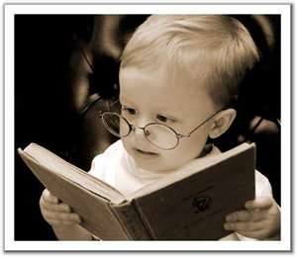

Sep 15 The Women by Kristin Hannah EX
Nov 17, 2025 Remarkably Bright Creatures by Shelby Van Pelt
Feb 16, 2026 The Clover Girls by Viola Shipman EX
Apr 20, 2026 The Woman They Could Not Silence
by Kate Moore EX
Jun 15, 2026 The Book Club for Troublesome Women
by Marie Bostwick

Website: www.mcleanhce.org

Do you have HCE Information to put on our public sites?
Website: Paula Miller- 309-824-0661 or pami2468@hotmail.com
Facebook: Robin Bagwell-309-750-6715 or bobbinlace@frontiernet.net
Newsletter: Pat Pulokas- 309-530-5327 or palp@mchsi.com

Like us at www.facebook.com/McLean-County-Association-for-Home-and-Community-Education-165077036864588/

McLean County HCE MEMBERSHIP Activities
Visit an HCE unit meeting, workshop, or class for wonderful lifelong learning.
For more information of HCE membership:

Paula Miller, 309-824-0661

Downs Unit – 1st Tuesday, 9:30 @ Downs Fire Station
Becky - 309-826-9559
Eastsiders Unit – 1st Friday, 9 a.m. – Extension Office
Debi – 309-825-8458
Night Owls Unit – 3rd Wednesday, 7 p.m. – various homes
Karen 309-830-6232 or Virginia – 401-451-7387
Towanda Unit – 2nd Monday, 6:30 p.m. – Towanda Community
Building Cindy – 309-824-4797
Sustaining Unit – lessons & information is emailed or mailed
to individual members but are also welcome to
attend any of the other unit or county HCE functions.
Joann, 309-310-9205, joannhart722@gmail.com

***** OCTOBER IS HCE MONTH! *****

Monthly Programs September through May, 2026
Coming to a Unit Meeting NEAR YOU!
More info: Kathleen, 309-824-2784, ksemery@frontiernet.net
Becky, 309-826-9559, becktohill@aol.com

LLL(Local Leader Lessons) are free & open to the public.
FB: Farm Bureau Auditorium, 2242 Westgate Dr, Bloomington

November –Herbal Teas – LLL McLean - LLL @ FB, Oct 28,
12:30-1:30p by Fusion Brew of downtown Normal

January, 2025- “Altering Recipes” LLL - Nov 25, 12:30-1:30p- @ FB
With Sara Attig, U of I Extension Family Life Educator

Minor Lessons for the rest of 2025 year will be on the International Study of South Africa
October – Foods and Traditions
November –Government & Flag

2026 Minor lessons/Country of Study is:
Caribbean Islands/Dominican Republic
January - Topic- History
February – Geography and Climate

SAVE THE DATE: HCE HOLIDAY PARTY
Saturday, Dec. 13, 9:30a.m. – 1 p.m.
St. Mary’s Church in Downs, IL More details SOON!

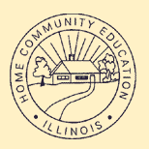 |   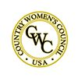 | 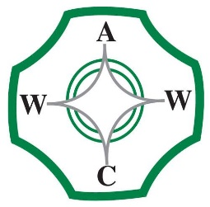

McLean County Association for Home and Community Education is affiliated with:

Illinois Association for Home & Community Education (IAHCE)

National Volunteer Outreach Network (NVON)

Country Women's Council USA (CWC)

Associated Country Women of the World (ACWW)

October 9, 2025
Information is subject to change Page 2

