McLean County Home and
Community Education News

APRIL  MAY  JUNE  2026 | 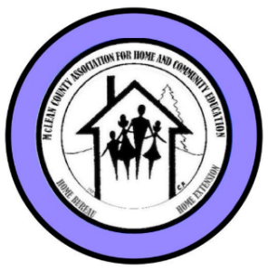
(All programs Open to Public, some with fees)
LLL = Local Leader Lesson
EX = Extension Office: 1615 Commerce Parkway, Blm
FB or FB=Farm Bureau Bldg, 2242 Westgate Dr, Blm

CULTURAL ENRICHMENT ACTIVITIES….

Trip to Amish Country – Arthur, IL
Thursday, April 23, 2026 Carpool to:
The Illinois Amish Heritage Center
Lunch at Yoder’s Kitchen
Shopping on your own - carpool together
More Info & RSVP - Donna, 309-829-2537

HCE POT PARTY  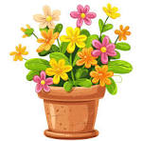  Thursday, May 14  9:30-11:30 am | AB Hatchery  916 E Grove Street, BLM  Build your own pot of flowers.  $5 class fee includes de mo, soil & fertilizer. 20% off other supplies of flowers, décor, pot (or bring your pot).  (Up to 10-12” pot suggested)  RSVP by May 12 to Pat  309-530-5327 Or palp@mchsi.com

BUSY CORNER LUNCH & SHOP
Tuesday., June 9 - 11 a.m.
Busy Corners Lunch  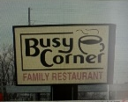  302 S Eureka St.  Goodfield, IL | Afterwards, Shopping  In Eureka!  RSVP by Fri, June 5  to Debi:  gaitedgal54@gmail.com  or call/text 309-825-8458  Carpooling on your own

Read & Share 2-3:30p  FREE Public invited  Info: LaVonne C. 309-661-6391 | 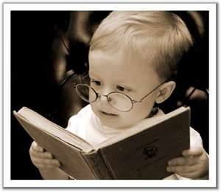

Apr 20, 2026 The Woman They Could Not Silence
by Kate Moore EX
Jun 15, 2026 The Book Club for Troublesome Women
by Marie Bostwick EX
Next Read & Share will start up in September, 2026

McLean County HCE MEMBERSHIP Activities
Visit a HCE unit meeting, workshop or class for wonderful lifelong learning.
For more information about HCE membership:

Paula Miller 309-824-0661
Pami2468@hotmail.com

Monthly Programs
Coming to a Unit Meeting NEAR YOU!
More info: Kathleen 309-824-2784, ksemery@frontiernet.net
Becky Toohill 309-532-2125, becktohill@aol.com

LLL(Local Leader Lessons) are free & open to the public.
FB: Farm Bureau Auditorium, 2242 Westgate Dr, Bloomington

April 2026 -Enjoying Gardening as We Age,
LLL –March 24, 12:30-1:30 p.m. Master Gardener
May 2026 – Weathering the Storm LLL – April 28, 12:30-1:30 p.m.
by Sara Attig, U of I, Family Life Educator
June 2026 Units involved in their own June Adventures
July 2026 108th Annual Meeting & YAH at the county fair

2026 Monthly Minor Lessons about:
Caribbean Islands/Dominican Republic

Jan.- History Feb.- Geography & Climate
March- Economy/Agriculture
April- People & Demographics May- Cities

International Co-Chairs:
Nancy Erickson: 309-825-4674
Rosemary Toohill: 309-962-5821

*** SAVE THE DATE ***
108TH HCE ANNUAL MEETING
& Fine Arts Show
McLean County Association for
Home & Community Education
Thursday, July 7, 2026 9am – 1:00pm
Church Lutheran Church
311 Hershey Rd, Normal

Enter fine arts projects completed within the past 2 years.
3
Questions/Tickets: Cindy Kelley, 309-824-4797
More details coming soon!
   | Experience The Magic  With  McLean County HCE  AND  Celebrate our Country’s  250th Year Anniversary
Watch for more details on HCE website: mcleanhce.org

HCE Community Volunteer Hours - CVH
Paula Miller, CVH chairman, would like your
2026 Volunteer hours Jan-June & July-December
Thank you for all the volunteer work you do!
Contact Info: 309-824-0661 Pami2468@hotmail.com

April 29, 2026
Information is subject to change Page 1
McLean Co HCE Newsletter
APRIL/MAY/JUNE 2026

108th YEAR  McLean County  Home & Community  Education | EXPERIENCE  THE MAGIC 2026

HCE COMMUNITY SERVICE DAY  Tuesday, May 19 ~ 9a-2p  Project: Walker bags, pillowcases  Ext. Office: 1615 Commerce Parkway, Blm  Come & go as needed | 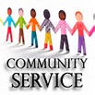

Time: 9a-2p. Cost: Free Open to the public
We get together to work on crafts or other special projects. Bring your own projects or we will work on HCE focus project. We have sewing machines. Sewers & non-sewers welcome. We need help ironing and cutting. Have fun while making things for others. Betty Jensen 309-531-2183
Next 2026 scheduled CS days: Jun 17 Aug 18

McLean County HCE SCHOLARSHIP NEWS

McLean County HCE Scholarship committee received 4 applications for the 2026 scholarship that will be awarded at the 108th Annual Meeting on July 7th at Christ Lutheran Church in Normal. Committee:
Robin Bagwell Sandy McGhee LaVonne Cunningham:
309-825-6558 or lavonnecunningham@gmail.com

FAMILY ISSUES/COMMUNITY SERVICE PROJECT

Gina McDannold JunkerGina@yahoo.com 309-242-3801

2026 collections for Humane Society of Central Illinois.

Bring different or the same items each month.

April - 30 gallon or larger garbage bags

May - paper towels or bleach

June- canned cat food(any kind) or poop bags

Also: store gift cards, Clorox wipes are acceptable

2026 NVON ANNUAL CONFERENCE
National Volunteer Outreach Network, Inc. NVON.org
July 14-16 – Wisconsin Dells
The Wisconsin Hotel & Conference Center
60 Gasser Rd, Wisconsin Dells, WI 53965
(608) 254-2285

Website: www.mcleanhce.org

Do you have HCE Information to put on our public sites?
Website: Paula Miller- 309-824-0661 or pami2468@hotmail.com
Facebook: Robin Bagwell- 309-750-6715 or bobbinlace@frontiernet.net
Newsletter: Pat Pulokas- 309-530-5327 or palp@mchsi.com

LIKE our facebook page at: McLean-County-Association-for-Home-and-Community-Education.

$$$ MONEY MATTERS $$$

3/20/26 FANNIE MAY FUNDRAISER – raised $387.23

Downs Bake Sale Booth - Wed, Jun 24 & Aug 12 4-6 p.m.

Downtown Bloomington Saturday Market - TBD

PICTURES (February-April)
Feb 14, 2026 Membership Tea  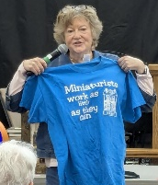  Beverly Keller presenter  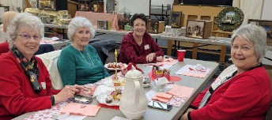  HCE Friends Enjoy Tea  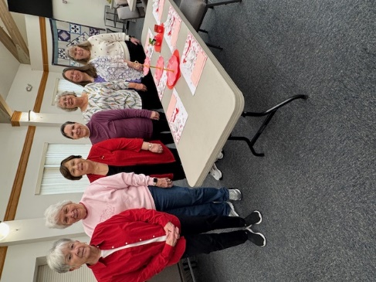  Eastsiders Unit set up workers  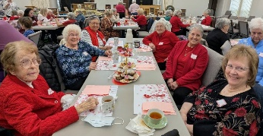  HCE Members & Guests  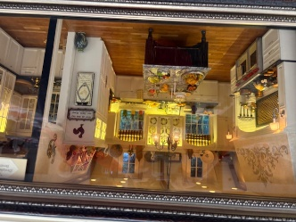  Bev Keller miniature display  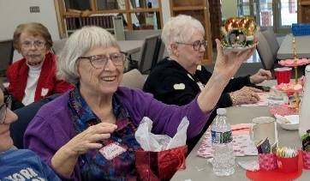  Eileen wins door prize miniature | IAHCE Annual Conference  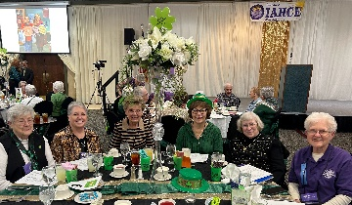  Cultural Enrichment Activities  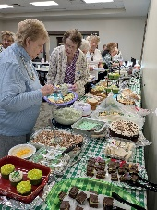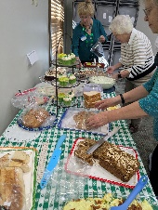  Sharing of the Green  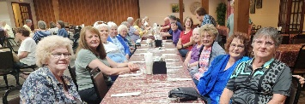  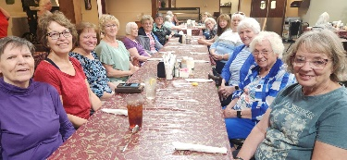  Visit to Yoder’s Kitchen in Arthur area  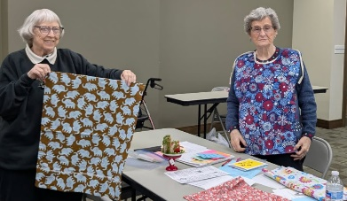  Community Service: Eileen -pillowcase & Betty with clothing protector  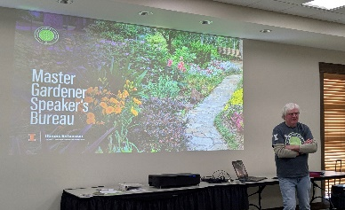  LLL -Enjoying Gardening As We Age

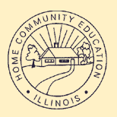 |   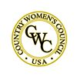 | 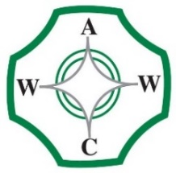

McLean County Association for Home and Community Education is affiliated with:

Illinois Association for Home & Community Education (IAHCE)

National Volunteer Outreach Network (NVON)

Country Women's Council USA (CWC)

Associated Country Women of the World (ACWW)

April 29, 2026
Information is subject to change Page 2

