McLean County Home and
Community Education News

July  AUGUST  SEPTEMBER  2026 | 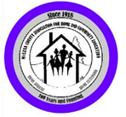
(All programs Open to Public, some with fees)
LLL = Local Leader Lesson
EX = Extension Office: 1615 Commerce Parkway, B
FB or FB=Farm Bureau Bldg, 2242 Westgate Dr, BLM

Experience the MAGIC !
CULTURAL ENRICHMENT ACTIVITIES….

Read & Share 2-3:30p  Meet at McLean Co Extension Ofc  FREE, Public invited.  Info: LaVonne C. 309-825-6558 | 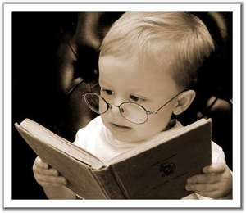

Jun 16 - The Extraordinary Life of Sam Hell by Robert Dugoni.
Sep 21 – The Little Old Lady Who Broke All the Rules
By Katherine Engelman Sunbird
Nov 16 – Theo of Golden by Allen Levi
Feb 15, 2027 – March by Geraldine Brooks
Apr 19, 2027 – The Book of Lost Names by Kristin Harmel
Jun 21, 2027 – The Silent Patient by Alex Michaelides

HCE INTERNATIONAL STUDY

2026  Caribbean/  Dominican Republic | 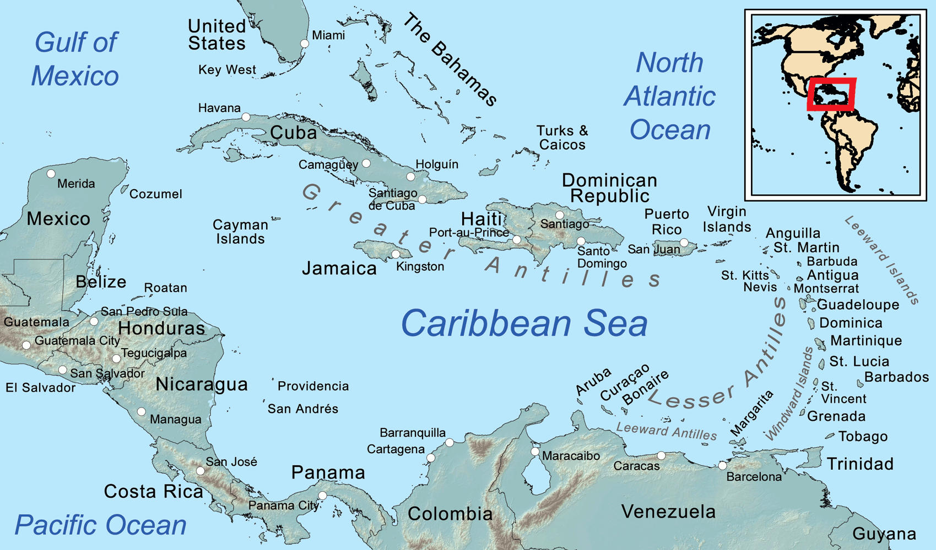
The word Caribbean has multiple uses. Its principal uses are geographical and political. The Caribbean word can be expanded to include territories with strong cultural and historical connections to Africa. Geologically, the Caribbean region is mainly a chain of islands surrounding the Caribbean Sea. To the north, the region is bordered by the Gulf of Mexico, the Straits of Florida and the Northern Atlantic Ocean, which lies to the east and northeast. To the south lies the coastline of the continent of South America.

** International Day, Thursday, October 1, 11a.m.-1p.m. **
McLean County Farm Bureau Auditorium
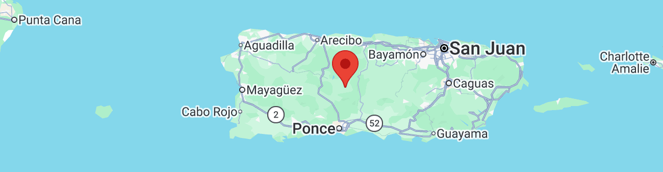
Google maps – Puerto Rico
Virginia Gobeli will speak on Puerto Rico

McLean County HCE MEMBERSHIP Activities
Visit an HCE unit meeting, workshop, or class for wonderful lifelong learning.
For more information about HCE membership:

Paula Miller, 309-824-0661, pami2468@hotmail.com

Monthly Programs (September – June)
Coming to a Unit Meeting NEAR YOU!
Kathleen 309-824-2784, ksemery@frontiernet.net
Becky Toohill 309-532-2125, becktohill@aol.com

LLL(Local Leader Lessons) are free & open to the public.
FB: Farm Bureau Auditorium, 2242 Westgate Dr, Bloomington

108TH HCE ANNUAL MEETING
& Fine Arts Show & Contest

Tuesday, July 7, 2026 8:30am – 1:00pm
Church Lutheran Church
311 Hershey Rd, Normal

Enter fine arts projects completed within the past 2 years.
3
Questions/Tickets: Cindy Kelley, 309-824-4797
Questions/Fine Arts Show: Debi 309-825-8458
   | Experience The Magic  AND  Celebrate our Country’s  250th Year Anniversary
8:30a Registration 9:10a Meeting 11:30a Lunch

Fine Arts & Craft Show judging will be going on with winners to go to state conference in March, announced after the program.

2026  McLean County Fair  And 4-H Show  July 29-Aug 2 | 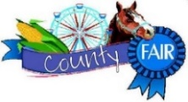

 | Thursday, July 30  Young at Heart Day at the  McLean County Fair  8:30-11:30am  Cloverleaf Auditorium

Refreshments, musical entertainment, Educational

booths of organizations serving seniors,

LOTS OF FUN and it’s FREE!

Call one of the Chairs for more information:

Cindy Kelley, 309-824-4797; Donna LaMar, 309-829-2537
YAH Planning Meeting: Thu, July 9, 7pm @ Donna’s

June 29, 2026
Information is subject to change Page 1

McLean Co HCE 2026 Newsletter
JULY AUGUST SEPTEMBER

108th YEAR  McLean County  Home & Community  Education | EXPERIENCE  THE MAGIC 2026

Serving the Community. . . . . . . . . .

HCE COMMUNITY SERVICE DAY  Tuesday, August 18 ~ 9a - 2p  Focus Project: to be determined  Extension Office:  1615 Commerce Parkway, Blm  Come & go as needed | 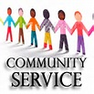
Time: 9a-2p. Cost: Free Open to the public
We get together to work on crafts or other special projects. Bring your own projects or we will work on HCE focus project. We have sewing machines. Sewers & non-sewers welcome. We need help ironing and cutting. Have fun while making things for others. Betty Jensen 309-531-2183
Next 2026 scheduled CS days: Aug 18 Sep 15 Oct 20
Questions: Betty Jensen, 309-531-2183 bjgrannie@hotmail.com

SOLDIER PROJECTS

We are collecting items for veterans.

Questions/Contact: Cindy Kelley 309-824-4797

FAMILY ISSUES

2026-2027 we will be collecting for a new organization:

Ministry and More Food Pantry, Bloomington, Illinois

Watch for new monthly collections schedule

Coordinator: Linda Conder

309-287-5588 conderlinda29@gmail.com

VOLUNTEER YOUR TIME with CVH
HCE Community Volunteer Hours – CVH Chair will collect your volunteer hours end of June & November. Contact info:
Paula Miller: 309-824-0661, pami2468@hotmail.com

McLean County HCE had also been an RSVP agency. As of July, 2026 YWCA will no longer serve as coordinators of the RSVP program since the program funding was eliminated.

National Volunteer Outreach Network
“Planting Many Seeds…Expect Growth”
NVON  27th Annual Conference  July 14-16, 2026  Springfield,  Illinois !!  Attending: Cindy Kelley, Pat Pulokas & Kathleen Emery |   www.nvon.org  (For more details)

Website: www.mcleanhce.org

Do you have HCE Information to put on our public sites?
Website: Paula Miller- 309-824-0661 or pami2468@hotmail.com
Facebook: Robin Bagwell- 309-750-6715 or bobbinlace@frontiernet.net
Newsletter: Pat Pulokas- 309-530-5327 or palp@mchsi.com

LIKE our facebook page at: McLean-County-Association-for-Home-and-Community-Education.
$$$ MONEY MATTERS $$$

2026 HCE Bake Sale Booths
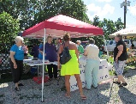 | Downs Village Market - Dooley Park  County HCE Wed, 4-6 p.m. Jun 25, Aug 12  Downs Unit Wed, 4-6 pm Jul 8, Sep 2  Towanda Farmers Market- Mondays  Pending applications (starts July 6)  Attic Treasures & Bake Sale  Fri, Oct 23 & Sat 24  Old Rugged Barn - Sat, Dec 5

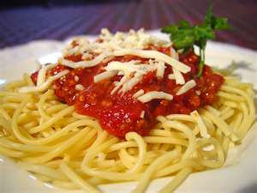  Avanti spaghetti, bread, salad homemade desserts  & drinks | Towanda HCE  Spaghetti Supper  Friday, July 3, 2026  4:30-6:30 pm  Towanda Community Building  At the door tickets:  Adult/$11 Child/$6 (2-7 yr)  Under 2 yr. FREE  309-824-4797

Towanda Fireworks when dark on Thurs., July 3, 2026

SAVE THE DATES:

HCE Attic Treasures & Bake Sale

Fri, Oct 23, 9a - 6p & Sat, Oct 24, 8a - 1p

McLean County Fairgrounds

Mini Expo Building

Holiday, Christmas, household, books, small furniture, linens, crafts, baked goods and so much more! We do NOT sell footwear or clothing, but we do sell purses, scarves,

and jewelry. More details- 309-824-4797

Set up & bring priced items on Thu, 9a-3pm.

Sale Proceeds to benefit: HCE Community Outreach Projects and HCE Scholarship Fund for 4-H.

IAHCE DISTRICT 2 WORKSHOPs

***Tuesday, June 30 - Mini meeting in Decatur, IL ***

11 am- lunch provided w/donation bucket

***Wed., August 5, 2026

Southern View Chapel, Springfield, IL

More details to come

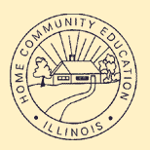 | 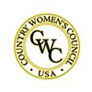 | 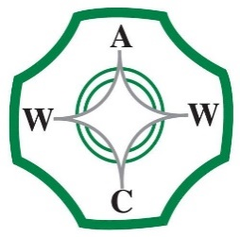

McLean County Association for Home and Community Education is affiliated with:

Illinois Association for Home & Community Education (IAHCE)

National Volunteer Outreach Network (NVON)

Country Women's Council USA (CWC)

Associated Country Women of the World (ACWW)

3
June 29, 2026
Information is subject to change Page 2

