McLean County Home and
Community Education News

AUGUST  SEPTEMBER  OCTOBER  2026 | 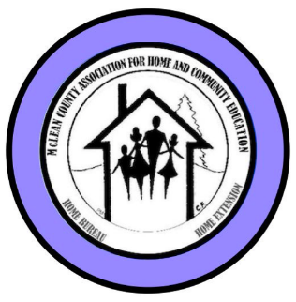
(All programs Open to Public, some with fees)
LLL = Local Leader Lesson
EX = Extension Office: 1615 Commerce Parkway, BLM
FB or FB=Farm Bureau Bldg, 2242 Westgate Dr, BLM

CULTURAL ENRICHMENT ACTIVITIES….….

Monday, Sept 21, 2-3:30 p.m. – Ext Office READ & SHARE The book: The Little Old Lady Who Broke All the Rules
by Catharina Ingelman-Sundberg
LaVonne Cunningham 309-825-6558

Wednesday, Oct 21, Cultural Enrichment: Tour of The Peoria Riverfront Museum & lunch at The Blue Duck Barbecue Tavern. MORE DETAILS SOON.

Nov 12, 9 a.m. – 12 noon – COOKIE EXCHANGE
More details to come. Contact Ruth Poppe:
grppoppe@frontier.com or text 309-287-8214

Monday, Nov 17, 2-3:30 p.m. – Ext Office READ & SHARE
The book: Theo of Golden by Allen Levi
LaVonne Cunningham 309-825-6558
__________________________________________________
Nov 5 IAHCE District 2 Mini Meeting
First Baptist Church, 1320 W Arbor Dr, Decatur
11 a.m. – Registration 11:30 a.m. Freewill lunch
__________________________________________________P

HCE INTERNATIONAL DAY – Puerto Rico
Thursday, October 1
11 a.m. – 1 p.m.

McLean County Farm Bureau
2242 Westgate Dr, Bloomington

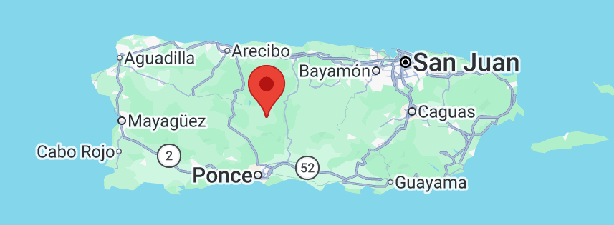
Google maps – Puerto Rico

Hear program, sample foods, enjoy learning new things!
Virginia Gobeli will speak of her experiences in Puerto Rico.
More Info: Nancy Erickson – 309-825-4674
McLEAN COUNTY HCE MEMBERSHIP

Visit an HCE unit meeting, workshop, or class for wonderful lifelong learning.
For more information about HCE membership:

Paula Miller, 309-824-0661, pami2468@hotmail.com

Monthly Programs (September – May)
Coming to a Unit Meeting NEAR YOU!
Kathleen 309-824-2784, ksemery@frontiernet.net
Becky Toohill 309-532-2125, becktohill@aol.com

LLL(Local Leader Lessons) are free & open to the public.
FB: Farm Bureau Auditorium, 2242 Westgate Dr, Bloomington

August 26: Super Tuesday at Farm Bureau Auditorium
8:30a - Exec Board 10:00a - Full Board
11:30a - 12:30p – Lunch, provided by board
1:30-2:30p LLL – “Route 66” - Terri Ryburn
2:30-3:30 pm - Unit Officers Orientation-

Sept Route 66, LLL @ FB, Tue,Aug 26, 12:30-1:30p
Oct The Underground Railroad -Personal Stories–
LLL-FB -Tue, Sep 22 12:30-1:30p
Nov- History of the Flag – LLL- @ FB, Tue, Oct 27 12:30-1:30p

2027
Jan- History of the Handbag LLL @ FB, Tue Nov 24 12:30-1:30p
Feb- Dementia LLL@FB, Tue Jan 26 12:30-1:30p
Experience    The Magic | HCE Minor Lessons for 2026  Sept Other Organizations HCE Members  are Associated With  Oct Illinois History with Recipes  Nov Fixing Nibbles for the Holidays

HCE ATTIC TREASURES SALE

Fri, Oct 23, 9 p.m. - 6 p.m.  Sat Oct 24, 8 a.m. - 1 p.m.  Interstate Center  Mini Expo Building  1106 Interstate Center Dr.,  Bloomington | 

Holiday, Christmas, household, books, small furniture, linens, Crafts, and so much more! We do NOT sell footwear or clothing, but we DO sell purses,

scarves, and jewelry.

More details- 309-824-4797

Members & Friends bring PRICED items, Thu, Oct 22, 9a-3p

Sale Proceeds to benefit:
McLean County HCE Community Outreach & Community Service Projects including scholarship(s) for 4-H

FAMILY ISSUES - COMMUNITY OUTREACH

2026-2027 special project to have collections this year is for

Ministry & More Food Pantry, Bloomington.

Sep – Full sized shampoo, conditioner, body wash/bar soap

Oct- Full sized toothpaste/brushes for adults & children

Nov- Lotion, razors, shave cream for women & men

Dec- deodorant, vitamins, OTC pain medicine for all ages.

Jan, 2027- pads, panty liners, tampons

Linda Conder, Chair - 309-287-5588 or

Conderlinda29@gmail.com
August 26, 2026
Information is subject to change Page 1
McLean Co HCE Newsletter
September/October 2026

109th YEAR  McLean County  Home & Community  Education | Experience  The Magic

Serving the Community. . . . . . . . . .

SOLDIER/VETERANS PROJECTS

Questions/Contact: Jane Callahan 309-531-1195

VOLUNTEER YOUR TIME
HCE Community Volunteer Hours – CVH Chair will accept
your volunteer hours at the end of June and November.
Contact info:
Paula Miller: 309-824-0661, pami2468@hotmail.com

October is HCE Month in McLean Co.

Save the Dates . . . . . . . . . . .

HCE Holiday Party

Saturday, Dec 5, 2026

8:30 a.m. – 1:00 p.m.

Ironwood Golf Course Clubhouse

Food, Bingo, Make-It, Take-Its

McLean County HCE

Membership/Friendship TEA

Saturday, February 13, 2027

9:30 – 11:30 a.m.

Registration starts at 8:30 a.m.

Christ Lutheran Church, Normal

309-825-8458

103rd IAHCE Annual Conference

March 16-18, 2027

Thelma Keller Convention Center

Effingham, IL

“There’s No Place Like Home”

Website: www.mcleanhce.org

Do you have HCE Information to put on our public sites?
Website: Paula Miller- 309-824-0661 or pami2468@hotmail.com
Facebook: Robin Bagwell- 309-750-6715 or bobbinlace@frontiernet.net
Newsletter: Pat Pulokas- 309-530-5327 or palp@mchsi.com

LIKE our facebook page at: McLean-County-Association-for-Home-and-Community-Education.

$$$ MONEY MATTERS $$$

2026 HCE Sale Booths Coming Up
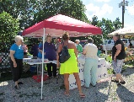 | Downs Village Market - Dooley Park  Wed, 4-6 p.m. Sep 9  HCE Attic Treasures Sale  Fri, Oct 23, 9a-6p; & Sat, Oct 24, 8a.–1p  Old Rugged Barn – Sat, Dec 5

PICTURES FROM SUMMER, 2026

108th Annual Meeting – July 7  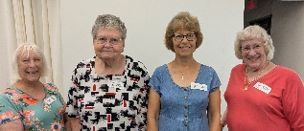  Past Presidents attend  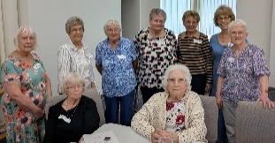  50+ Year members attending  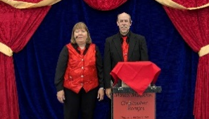  Magic by Christopher Bontjes  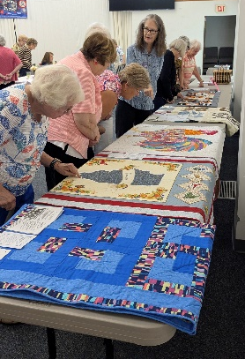  Cultural Enrichment Show  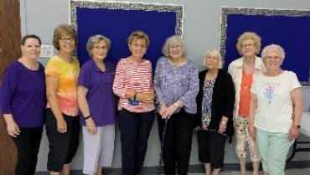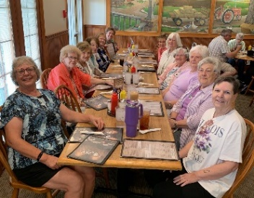  Attendees at District 2 in June | Young at Heart – July 30  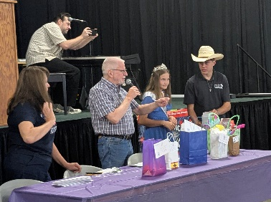  Don calls door prize winners  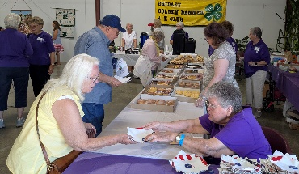  Lot’s of Food & Drinks  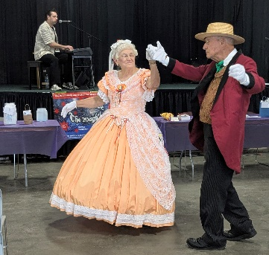  Dancers & Entertainment  Busy Corners Lunch Out in June

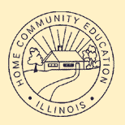 |   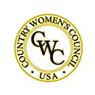 | 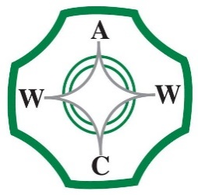

McLean County Association for Home and Community Education is affiliated with:

Illinois Association for Home & Community Education (IAHCE)

National Volunteer Outreach Network (NVON)

Country Women's Council USA (CWC)

Associated Country Women of the World (ACWW)

3August 26, 2026
Information is subject to change Page 2

